**Chapter 3 Answer**

1. (-3, 0) 2. Infinite Solutions 3. (5, 1) 4. (4, 1) 5. No Solution 6. (5, -½)

7. Infinite Solutions 8. (0, 5/2) 9. 12, 8 10. 8 petunias, 16 daisies

11. l = 32 ft., w = 20 ft. 12. Froot Loops: $3.25, Kix: $2.65

**Chapter 4 Answers**

1. 7*x* 2. -2*x* – 1 3.  4. 

5.  6.  7.  8. 

9.  10. False 11. True 12. True

13. (*x* – 5)(*x* + 2) 14. 2(*y* – 5)(*y* + 5) 15.  16. (4*a* – 3)(*a* + 1)

17. *x*(*x* + 10)(*x* – 7) 18.  19.  20. 

21. 5(3*x* – 4*y*)(3*x* + 4*y*) 22.  23. (*c* + 7)(*c* – 1) 24. 3(2*x* + 3)(*x* – 2)

25. *x* = 5, -3 26. *c* = 0, 5 27.  28. -5 – 12*i*

29. 3 – *i*  30. 15 – 2*i* 31. 11 – 7*i* 32. -4 – 33*i*

33. 25 34.  35.  36. 

37.  38. 

39. *x* = 5, -3 40. *x* = 3, -1 41. 

42.  Vertex: (-5, -5) AoS: *x* = -5 Opens Up

43.  Vertex: (-4, -3) AoS: *x* = -4 Opens Up

44. Disc: 16, 2 Real Roots

45. Disc: 0, 1 Real Root 46. Disc: -196, 2 Imaginary Roots

47.  48.  49. Aos: *x* = 4, Vertex: (4, 19)

Domain: $\left(-∞,∞\right)$ Range: $\left(-∞,\left.19\right]\right.$

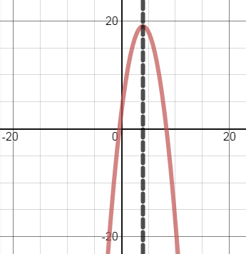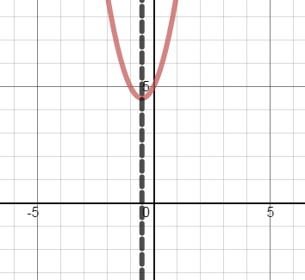50. AoS: , Vertex: 

Domain: Range:

51. *a* and *c*  must both be positive 52. $17.50 per book, $6,125 max income 53. *x* = -3, 2 54. 12 m by 8 m

**Chapter 5 Answers**

1.  2.  3.  4.  5. 

6.  7.  8.  9.  10. 

11.  12.  13.  14. 

15.  16.  17. *f*(2) = -4, *f*(-1) = -7

18. *f*(2) = -22, *f*(-2) = 20 19. *p*(-1) = 7, *p*(2) = 1 20. *p*(-1) = 0, *p*(2) = -3

21. (*x* – 2)(*x* + 4)(*x* + 1) 22. (*x* – 3)(2*x* – 1)(2*x* + 1) 23. , Two Real,Two Imaginary

24. ; 3 Real 2 Imaginary 25. *x* = 2, -2, 1, -1; 4 Real

26.  27.  28. *x* = -2, 2, 3 29. 

30.  31. 

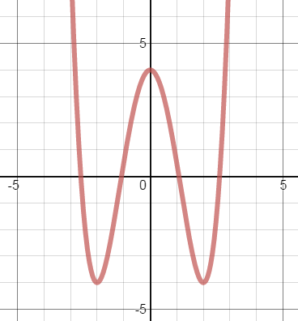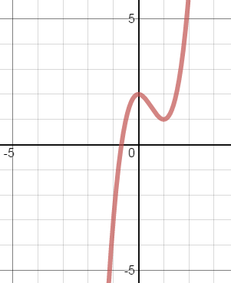

32. Z: (-.7, 0), Max: (0, 2), Min: (1, 1) 33. Z: (-2.6, 0) ( 2.6, 0)

Domain: $\left(-∞,∞\right)$ (-1.1, 0) (1.1, 0)

Range: $\left(-∞,∞\right)$ Max: (0, 4)

Min: (-2, -4) (2, -4)

Domain: $\left(-∞,∞\right)$

Range: $\left[-4\right.,\left.∞\right)$

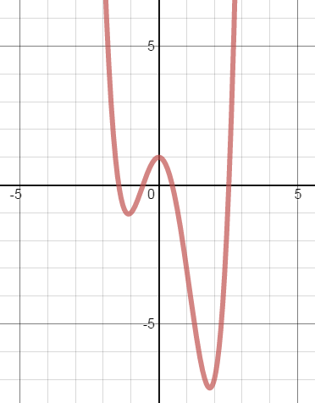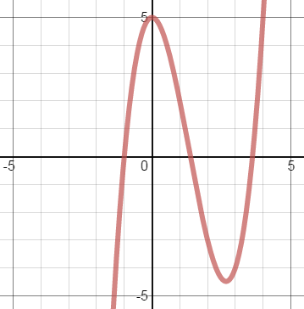34. Z: (-1, 0), (1.4, 0) (3.6, 0) 35. Z: (-1.4, 0) ( -0.6, 0)

Max: (0, 5), Min: (2.7, 4.5) (0.5, 0) (2.5, 0)

Domain: $\left(-∞,∞\right)$ Max: (0, 1)   
 Range: $\left(-∞,∞\right)$ Min: (-1.1, -1.0) (1.8, -7.3)

Domain:

Range:

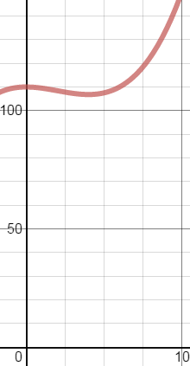

36. Min: (4, 106.8) , Not Reasonable

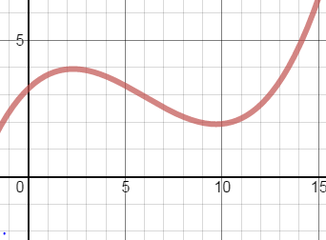37. Max: (2.3, 3.9) , Increases through May and decreases   
 Min: (10, 1.93) through to October.

38.  39.  40. 

**Chapter 6 Answers**

1. -11 2. 2 3. 4 4.  5. 

6.  7.  8.  9.  10. 

11.  12. 10 13.  14.  15. 

16.  17.  18.  19.  20. 

21.  22.  23.  24.  25. 

26.  27.  28.  29.  30. 

31.  32.  33.  34. 52 35. 2

36. 4 37. 0 38. 39. 12 40. 4

41. 32 42. 4 43. 44.  45. 

46. yes,  47. yes,  48. 

49.  50.  D: 51.  D:

52.  D: 53. 

54. 22 55.  D:

56.  D: 57.  D:

58.  D: 59.  D:

60.  61. 

**Chapter 11 Answers**

1. Mean: $5.14 Median: $4.85 Mode: $4.75

2. b. 13 c. 93 d. 80 e. 54.4 f. 45 g. 54.5 j. 45 k. 67 l. 22 m. 33 n. 12 o. 100 p. None

3. a. 5.6% b. 40.4% - 51.6% c. 400

4. a. 145.7 lbs b. 13.1 lbs c. Numbers at the bottom of the distribution 106.4, 119.5, 132.6, 145.7, 158.8, 171.9, 185

d. 132.6 and 158.5 e. 119.5 and 171.9 f. 185 g. -0.82 h. 0.62%